

**Ten Practices to Entrain Your Brain**

These mindfulness activities are adapted from *How to Train a Wild Elephant and Other Adventures in Mindfulness* by Jan Chozen Bays, M.D.

Mindfulness: deliberately paying full attention to what is happening around you and within you-- in your body, heart, and mind. Mindfulness is awareness without judgment. Doing these activities entrains your brain and allows your brain to be open to new experiences.

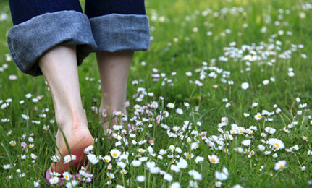

**The Great Earth Beneath You.** As often as possible, become aware of the earth beneath you. Become aware through sight and touch, especially the touches on the bottoms of your feet. When you are not outside, you can use your imagination to “feel” the earth beneath the floor you are on or the building you are in.



**Your Tongue.** While eating or drinking, become aware of your tongue. When you notice your mind wandering during a meal, return it to awareness of your tongue. It helps to ask questions such as, “What is my tongue doing or feeling right now?” Become aware of the changing experiences of temperature, texture, flavor, and spiciness. Where does it sense various flavors most acutely? How is your tongue moving?



**Look Up!** Several times a day, deliberately look up. Take a few minutes to really look at the ceiling in rooms, at tall buildings, at the tops of trees, at roof, at hills or mountains, and at the sky. See what new things you notice.



**Light.** Expand your awareness of light in all its forms, bright and dim, direct and reflected.



**Appreciate your hands.** Several times a day, when your hands are busy. Watch them as though they belonged to a stranger. Also, look at them when they are still.



**Listen to sounds.** Several times a day, stop and just listen. Open your hearing 360°, as if your ears were radar dishes. Listen to the obvious sounds and the subtle sounds-in your body, in the room, in the building, and outside. Listen as if you had just landed on another planet and didn't know what was making the sounds. See if you can hear all sounds as music being played just for you.



**See the color blue.** Become aware of the color blue wherever it appears in your environment. Look not just for obvious instances such as the sky but also for subtle appearances and for all the variations of blue.



**Notice smells.** During the day, as often as possible, become aware of smells or fragrances. This maybe easiest during meals or when cooking. Try sniffing the air sort of like a dog does. If there are smells in your environment, create some that you can detect. Dab some scent on your wrist, boil some spices such as cinnamon or close on the stove. Try lighting a few scented candles or burn some incense.



**Appreciation.** Stop throughout the day and consciously identify what you can appreciate in the present moment. It could be something about yourself, another person, your environment, or what your body is doing or sensing. This is an investigation. Be curious, asking yourself,” Is there anything I can appreciate right now?”



**Silly walking.** Several times a day, especially when your state of mind is not optimal, do a silly walk of some kind. Examples: skipping, backwards, hopping on 1 foot. Watch what happens to your state of mind or your mood as you walk the silly way.



**Entering new spaces.** Before you walk through a doorway, pause, even for a second and take three deep breaths. Be aware of the differences you might feel in each new space you enter. Also, pay attention to how you close the door.